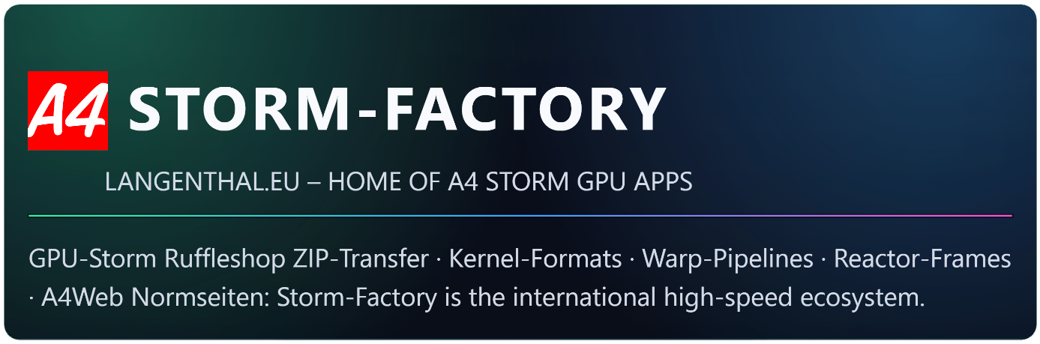
CUSTOMER DATA SHEET – A4 STORM FILE TRANSFER

ADDRESS INFORMATION
Country:
City / Location:
Customer Name:
Address:
Phone:
Email:
Webmaster Email
for Ruffleshop:
Ruffleshop-URL:  (your domaine + /ruffleshop) | https://www.XXXXX.XX/ruffleshop/

STORM MODULES
EDITION: | 055-EUR-Germany-Gold-Family-4-Kernels-Bundle EUR 500.- (overwrite)
CURRENCY: | EUR (overwrite your currency for Ruffleshop Shopping Cart here)
LANGUAGE: | Deutsch (overwrite your language for Ruffleshop Shopping Cart here)
HTML-MODULE 1: | yes
SEARCH-MODULE 2: | yes
Price: | Family-4-Kernels-Bundle = 500.- (Example, please overwrite)  MODULES 1 + 2 = 180.- (Example, please overwrite)  Total EUR: 680.- (Example, please overwrite)
Date of payment:
Account: | A4Web Langenthaler.ch Langenthal Andreas Lützenberger  IBAN: CH90 0900 0000 9138 1476 8  BIC: POFICHBEXXX  Message: Ruffleshop EUR  SWIFT CODE ADDRESS:  POFICHBEXXX  PostFinance AG  CH-3030 Bern
Total amount EUR: | EUR 680.- (overwrite)
Received money on:
ZIP Transfer Date:
Notes:
(Copy of email order)

